KELCO INDUSTRIES
MARKETING TO ROI
PROCESS FLOW

Login To Role: Marketing Manager
Setting up Marketing Preferences:
Navigate to Setup Marketing Marketing Preferences.
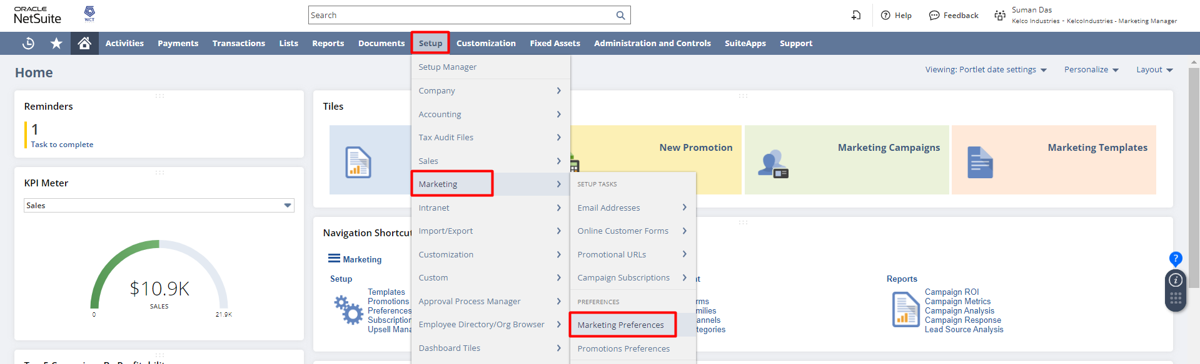
Review and update any preferences based on your requirements. For detailed information regarding a preference click on the field label and review the field label help. Click Save.
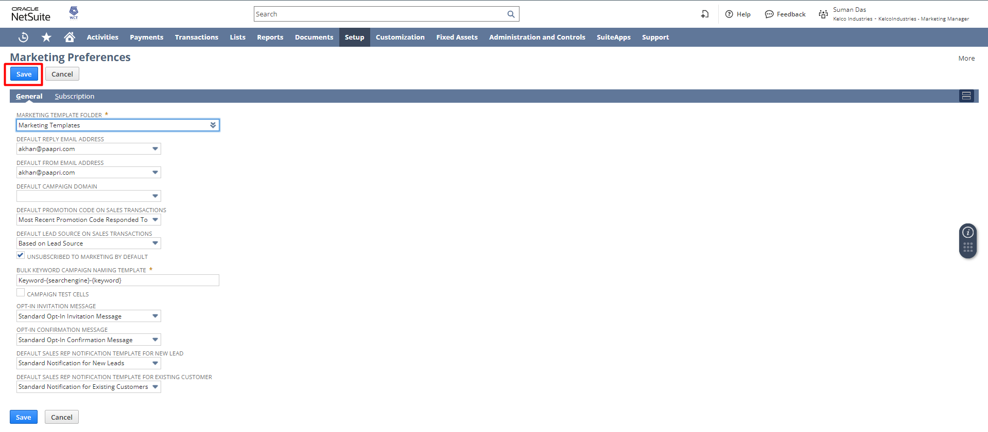

The following steps are to be followed to create a Marketing Campaign.
STEP 1: Setting up a Campaign Email Address:
Navigate to Setup Marketing Email Address New.
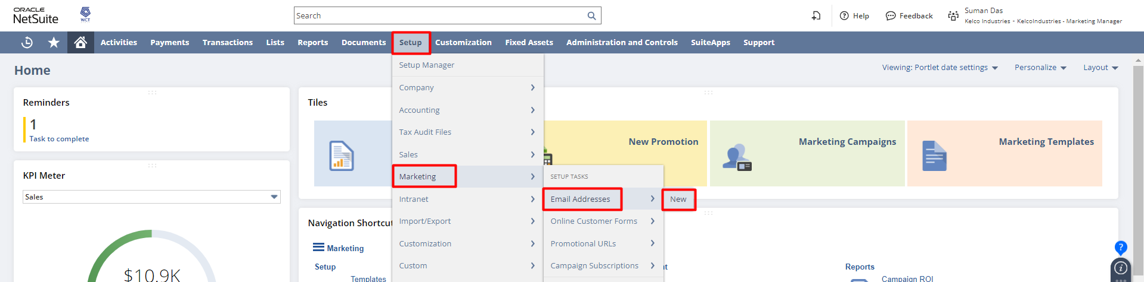
The user must have a Campaign E-mail Address to send the campaign email. This email can be viewed by all the customers to whom these campaigns have been sent.
On the Campaign Email Address page, enter the email address you want to use.
If you check the Private box, only the person who entered this campaign email address record can:
  - View this email address record.
  - Assign this email address to email templates
Click Save.
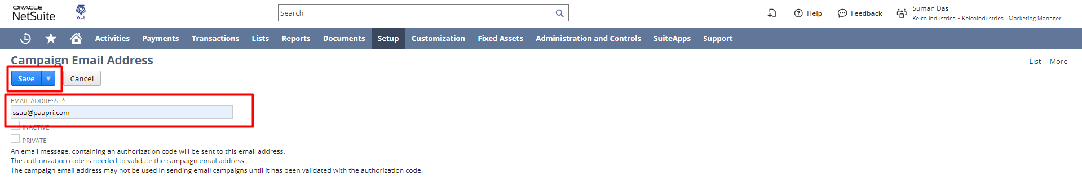
NetSuite sends an authorization code to the email address when you save the email record. Before you can use this email address, you must enter the authorization code in the campaign email address record from the email sent to you by NetSuite.
After saving, it will open the List of Campaign Email Addresses. Here we can see the email is successfully saved, but not yet validated.
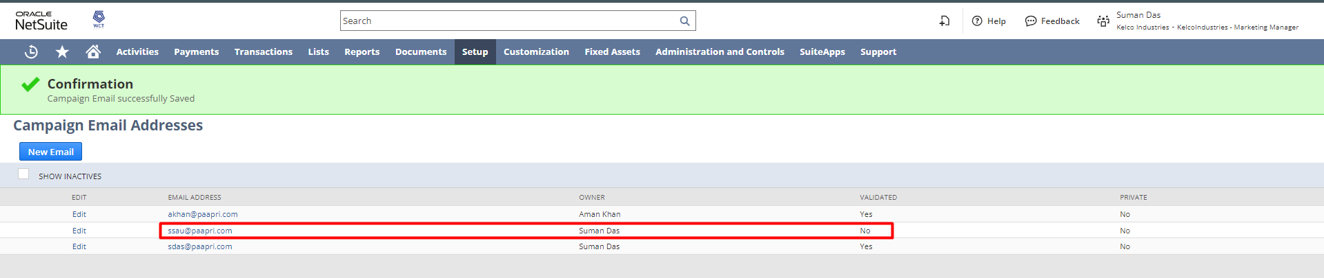

Validating Campaign Email Address:
Navigate to Setup Marketing Email Addresses.
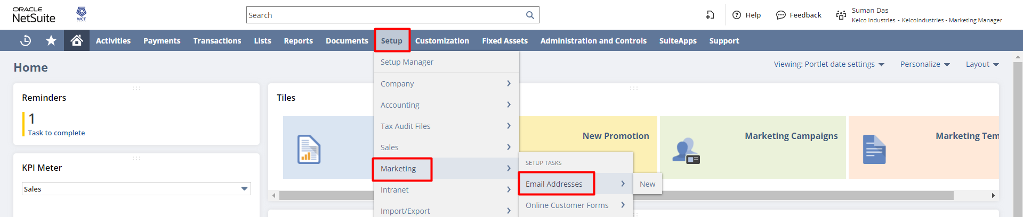
This will open the List of Campaign Email Addresses.
Click Edit next to the email address you want to validate.
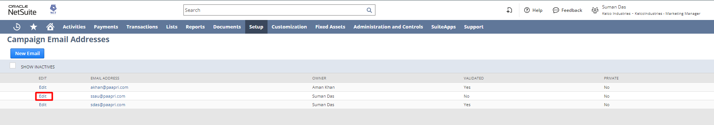
In the Authentication Code field, enter the code sent to you via email by NetSuite when you saved the record. Click Save.
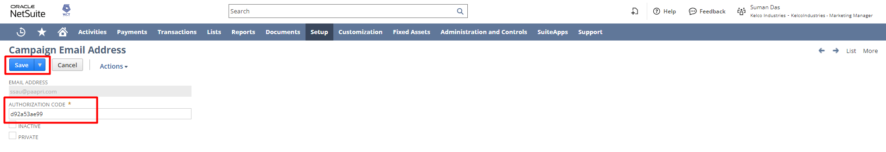
The Email is now validated. 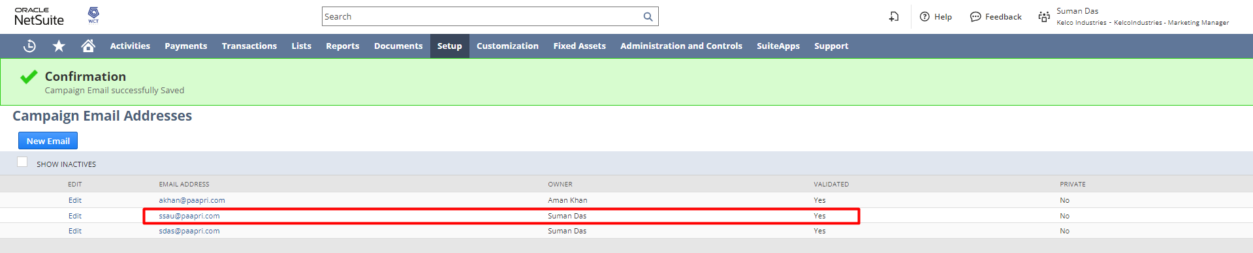

STEP 2: Create Marketing Templates:
Navigate to Lists Marketing Marketing Templates New.
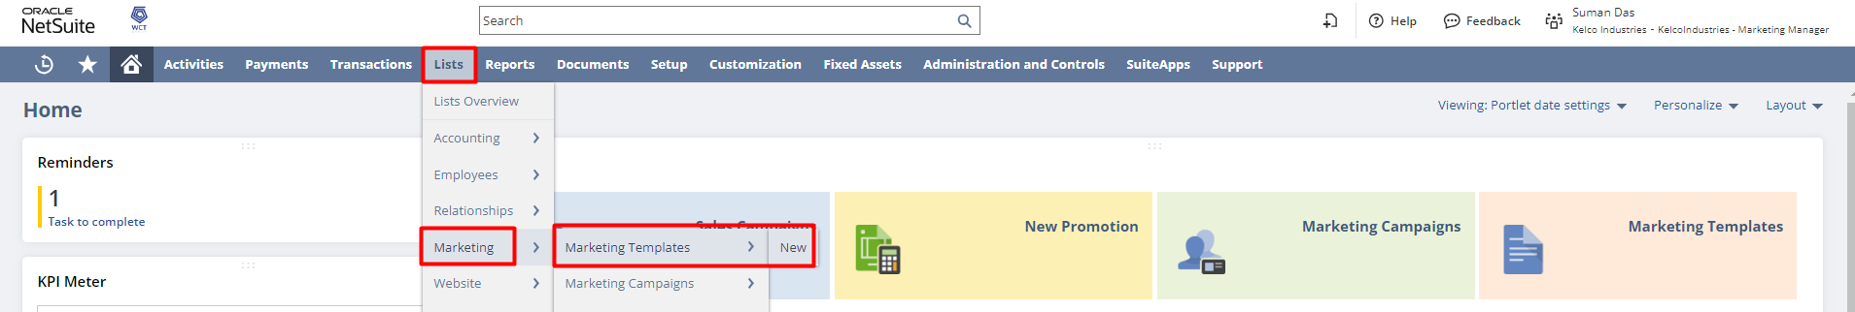

On the delivery date for the campaign event, NetSuite uses the campaign template to generate the email you send to the target group.

On the Select Type page, click Campaign. 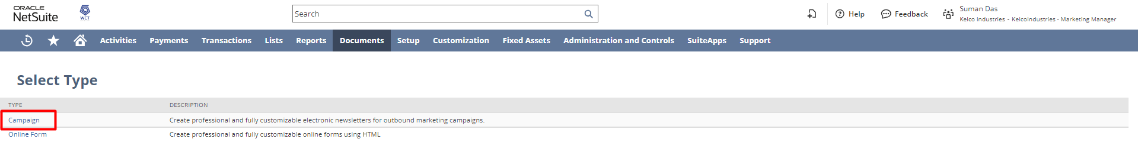

Select the template layout you want to use to design your template.
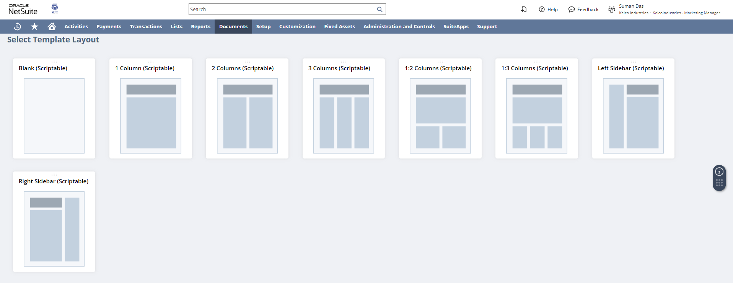
On the New Campaign Email Template page, enter a name for this template. Enter a description for this template.
- To send a preview of the email template, check the Send Email Preview box, and enter the email address to which you want to send a preview.
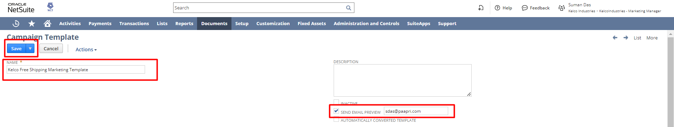
Under the Template subtab, upload a file you prepared outside of NetSuite. You can also create the template with the text editing options in the Template field.
- In the Subject field, enter a subject for the email you send with this template.
- You can do one of the following:
  - Choose File if you created the template beforehand, and then select the template file in the list. You can also click New if you have not already uploaded your template file to your file cabinet.
  - Select Text Editor if you have not yet created your template, and then compose your template in the rich text field.
- To insert a field in the template, select the record type in the Field Type list. Then, select a field in the Insert Field list.
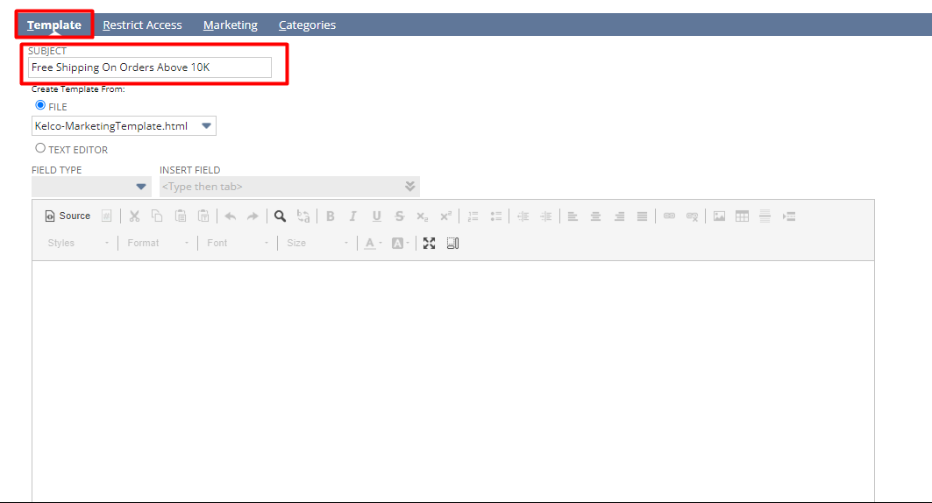

Under the Marketing Subtab, you can see below a brief explanation of the fields present in the marketing subtab.
- From Name field: enter the name you want to appear in the From field on email messages you send with this template.
- From Email Address field: select a validated email address to appear in the From field of your marketing email.
- Reply to Email address field: select a validated email address to receive responses to your marketing email.
- Check the Email as Sales Rep box if you want replies to the email to be sent to the sales rep assigned to customer recipients.
- Campaign Domain field: select the campaign domain you want to use for this template.
- Subscription field: select the category of campaign subscription that this email template is used for.
- To track statistics related to how often this email message is opened or clicked through, check the Track Outgoing Email box.
Click Save. 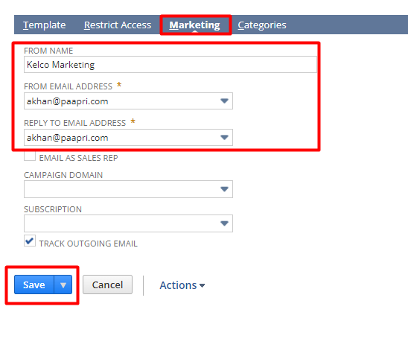

Step 3: Create a Target Group of Customers for Email Campaign
Email and direct mail campaign events target segments of customers, prospects, or leads. You can create new customer groups based on purchased items, purchase dates, and purchase amounts. You can also create groups based on location, customer category, or lead source.
Navigate to Lists Relationships Groups New.
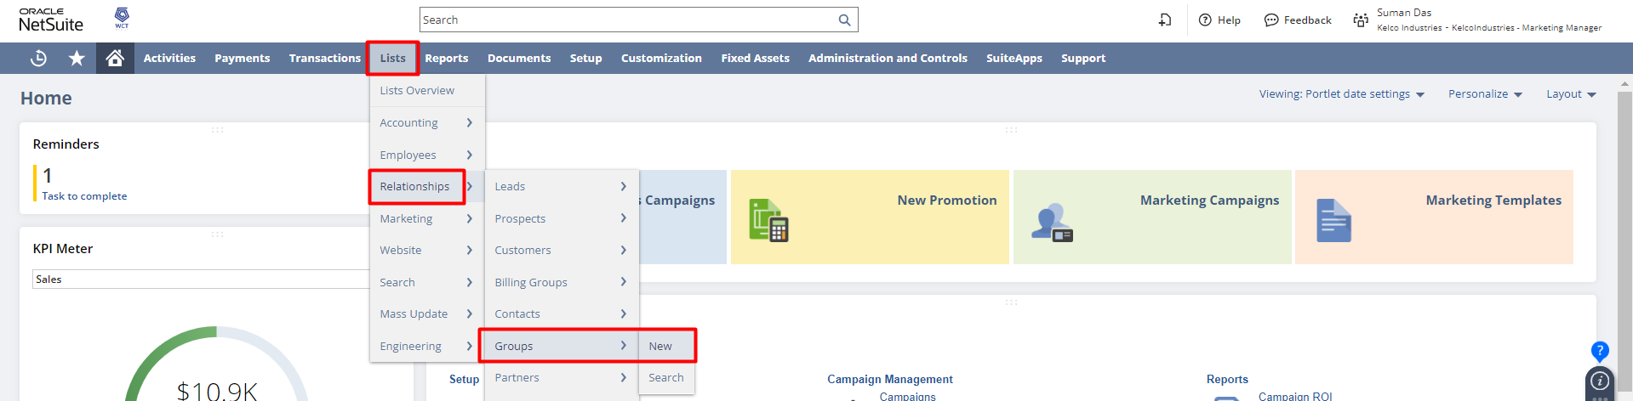

- Select group type as per your requirement
You can create two types of groups:
- Dynamic groups – Dynamic group membership changes to include anyone who meets the group's criteria (uses NetSuite saved searches to determine who are part of the group. For Eg. If a particular category of customers is to be part of the group, the user can create a saved search for the same and select it. Doing so will allow existing as well as new customers to be dynamically added to the group.)
- Static groups – The membership of static groups does not change.

To create a Static Group:
- On the Create Group page, choose Static.
- Choose the kind of members you would like this group to contain. (Customer)
- Click Continue.
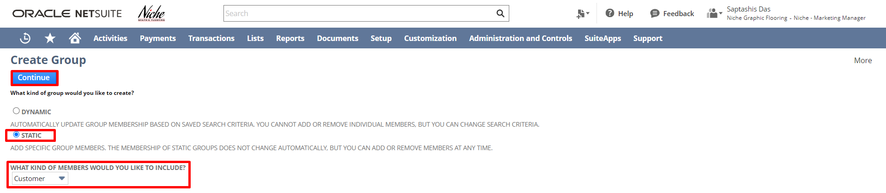
  - Enter a name for this group.
- If applicable, complete the following:
  - If the owner of this group is someone else, select that person in the Owner field.
  - If this group shares an email alias, enter the email address in the Email field.
  - Enter other information about this group in the Comments field.
  - Check the Private box if you want to restrict viewing (and also editing) of this group to its members.
  - If you want to restrict access to this group to members of another group, select the group in the Restrict to the field.
  - Check the Restrict Group Editing to Owner box if you want to restrict editing permissions to the group owner as specified in the Owner field.
- You should enable Restrict Group Editing to Owner preference whenever you are setting up a group to control access to sensitive information.
  - Under the Members subtab, do one or more of the following:
  - To add individual members, enter part of a member's name in the Name column, and press Tab. Select a member, and click Add. Repeat these steps for each member.
  - Click Add Multiple and hold CTRL to select more than one member from the list.
  - Click Add with Search to enter the search criteria for the members you want to add.
Click Save.
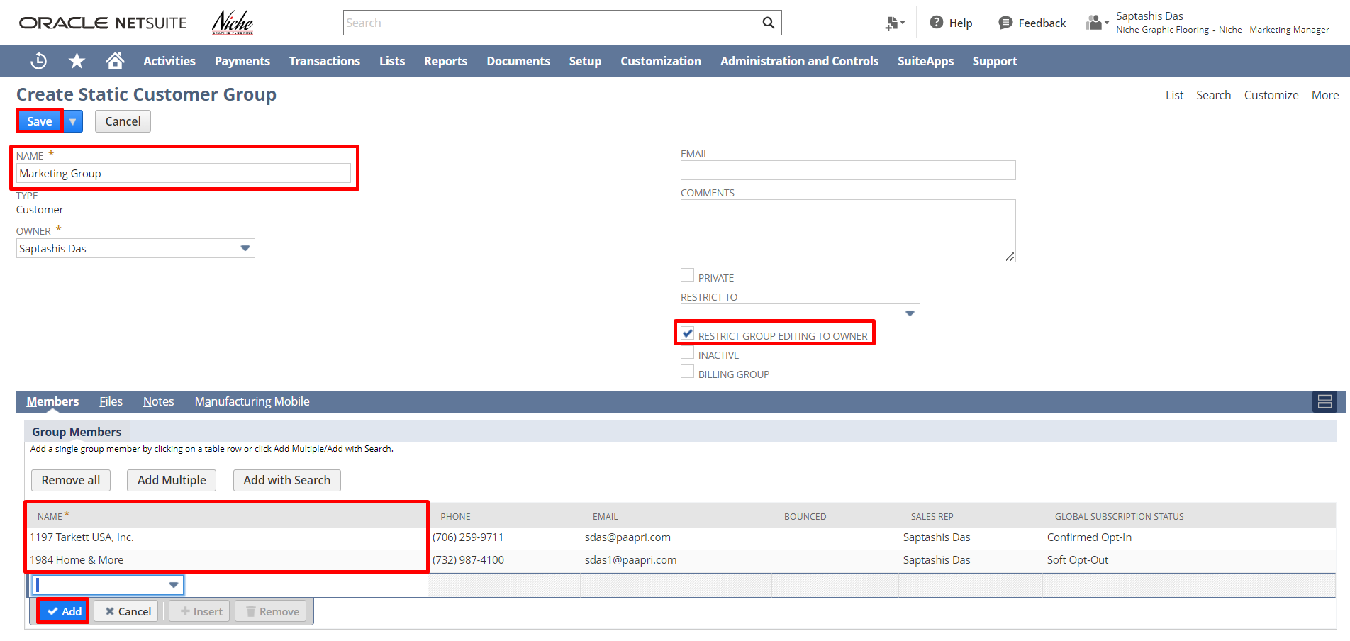

Step 4: Setting Up Subscriptions for Customers:
Navigate to Lists Relationships Customers.
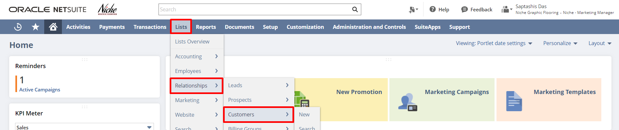
To give subscriptions to customers you need to open the customer’s list using the below navigation and edit the customer record. Click On the Edit Button and go to that customer record.
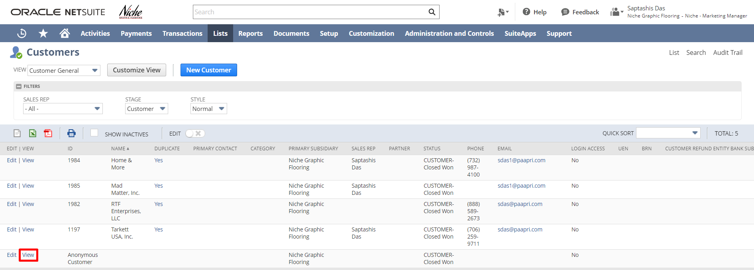
Under the Marketing Subtab, click on the Subscription tab, to see the GLOBAL SUBSCRIPTION STATUS field, Select Soft Opt-In/ Confirm Soft Opt-In and check those checkboxes under the Subscribed section to give the user’s customer subscription.
- Soft Opt-Out: Recipients with this status do not receive campaign email messages or bulk email messages, but they do receive opt-in messages.
- Soft Opt-In: Recipients with this status receive all email marketing campaigns or bulk emails received by recipients with the Confirmed Opt-In status. They also receive opt-in messages that enable them to confirm whether they want to receive email campaigns or bulk emails.

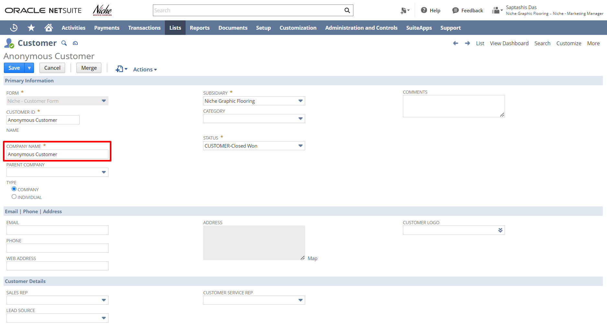
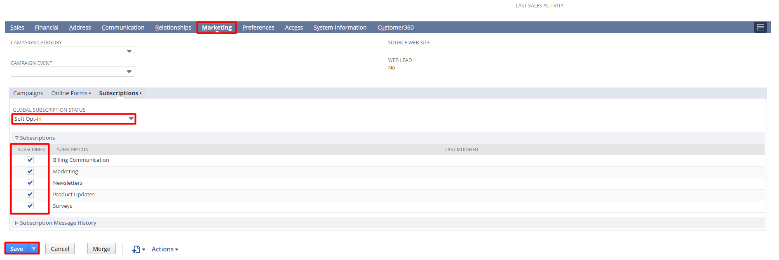

NOTE: To send campaign emails to the customers, GLOBAL SUBSCRIPTION STATUS should be ‘Soft-Opt-In’. and the required Subscriptions need to be checked.
Click ‘Save’.

STEP 5: Create a Promotion
Navigate to Lists Marketing Promotions New.
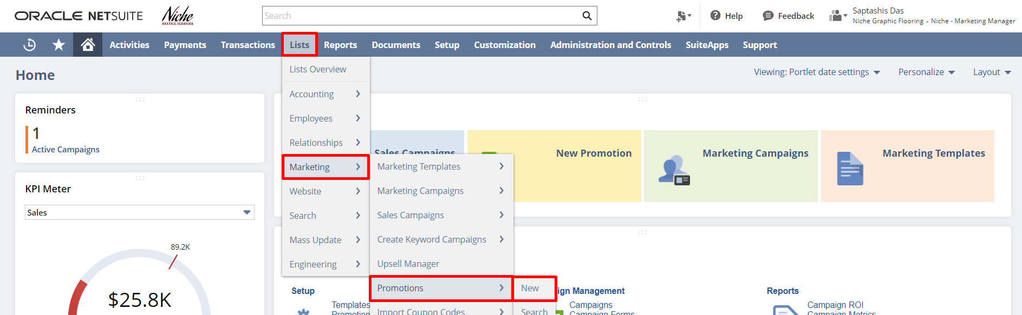
Promotions enable you to create special offers to motivate your customers to purchase products in higher quantities. Promotions can help you to move out-of-date stock, increase sales, and reward valuable clients. Promotions provide discounts that customers can apply to web store orders and orders placed with sales reps. Furthermore, NetSuite promotions enable you to target specific customers, locations or channels, and periods.
- To create a “Promotion” click on the icons below:
- For Example: Click on “Shipping Promotion”.

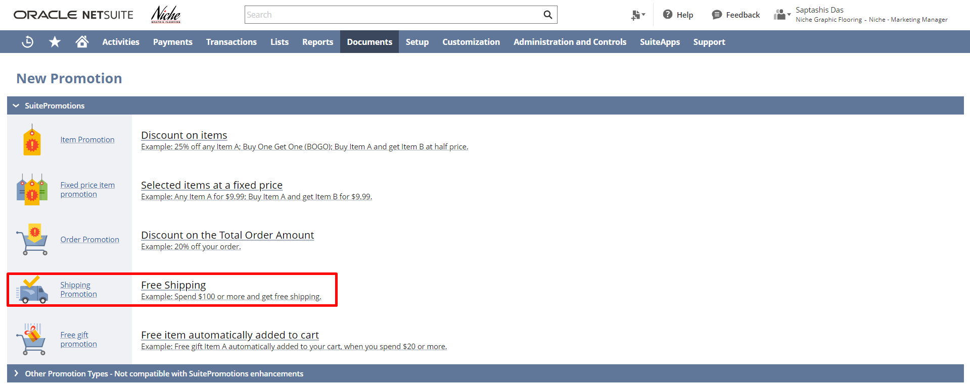
This will open the Item promotion page where you can fill in the necessary details,
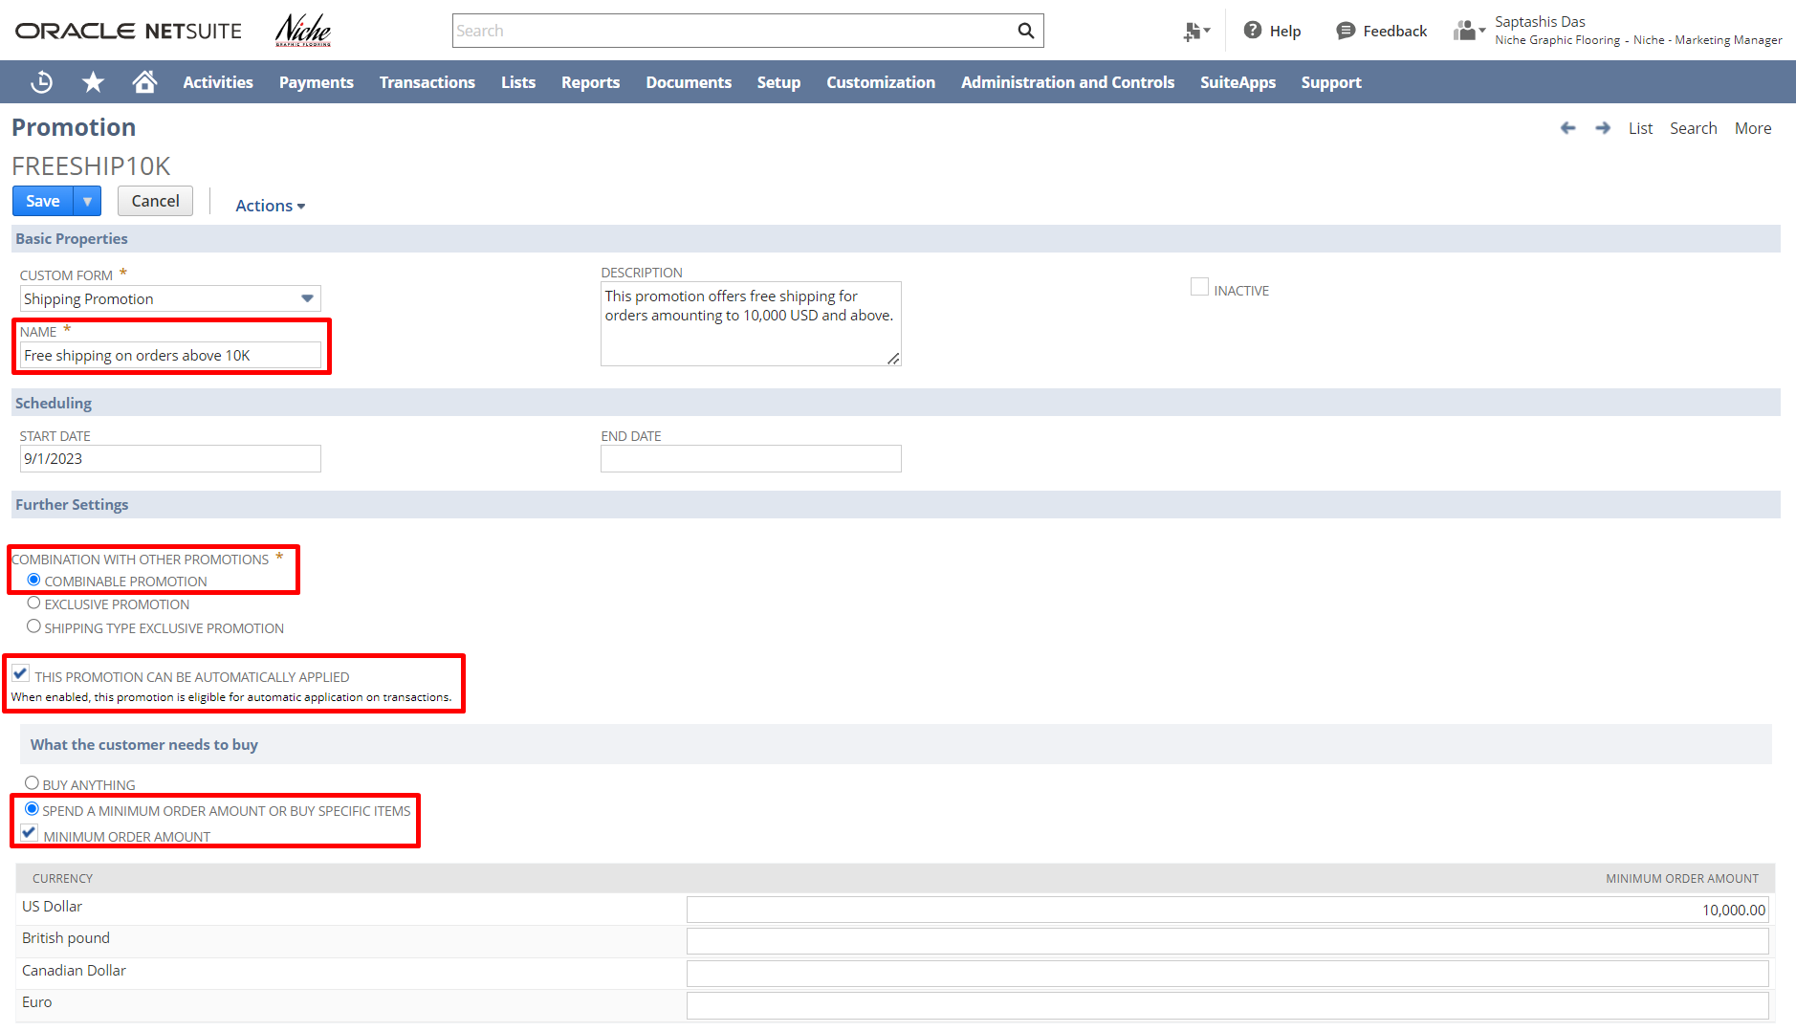

Under The Coupon Codes subtab, you can select the Coupon Code Type and Coupon Code Name.
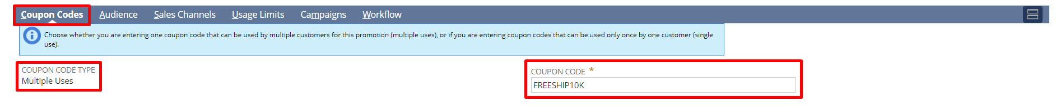
Under the Audience subtab, select Audience for this promotion.
Note: Audiences can be specific customers or all the customers present in the system.
Under the Usage Limits subtab, you can select the limit up to which Each Customer Can Use the Promotion.
- Click Save.
- Now a Promotion named Free Shipping on Orders above 10k has been created and sent to the Customers through Email.
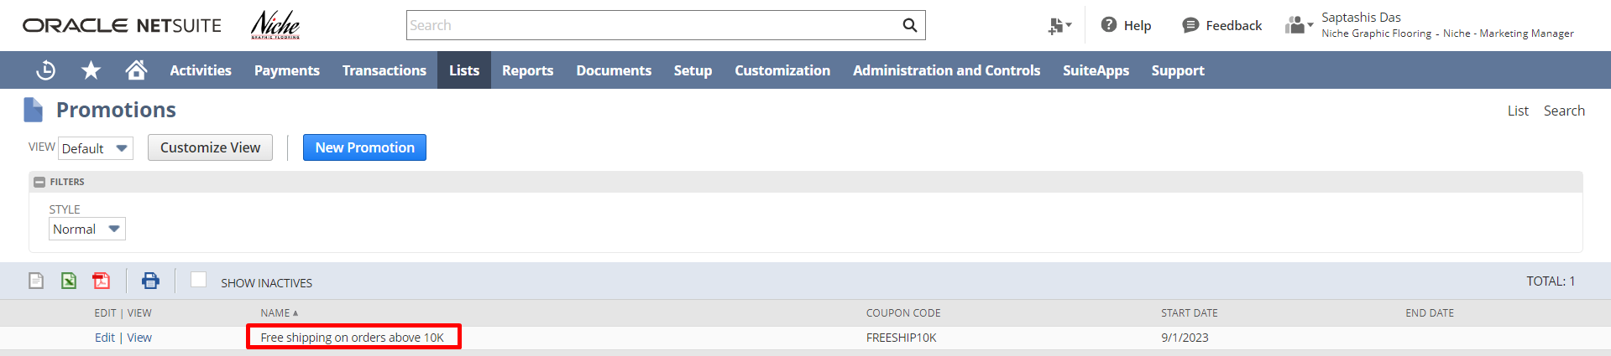

STEP 6: Creating a Marketing Campaign.
Creating a Marketing Campaign:
Navigate to Lists Marketing Marketing Campaign New.
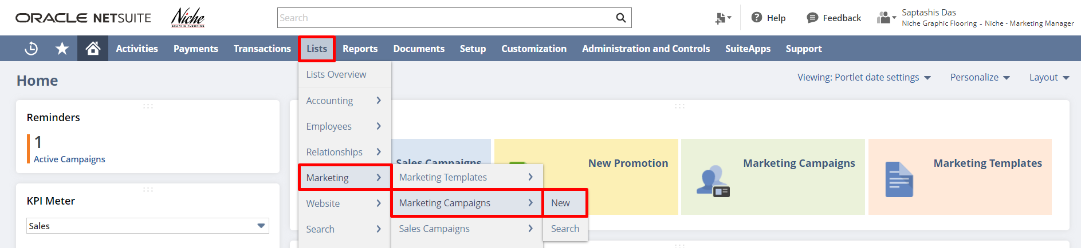
Enter The Title for the campaign. Select the Manager (if any). Select the Items for Promotion. Select the Start Date, End Date, and Promotion Code (if any).
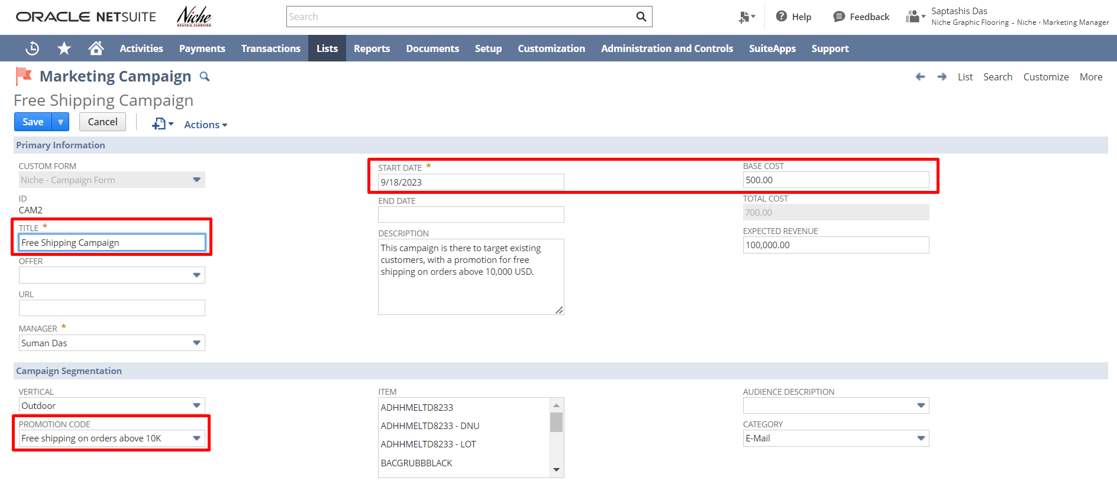
Under the Event Subtab,
- Select the Target group,
- Select Template.
- Select Subscription.
- Select Channel.
- Select Status.
- Enter the Execution Date and time.
- Click Add.
- After this click Save.

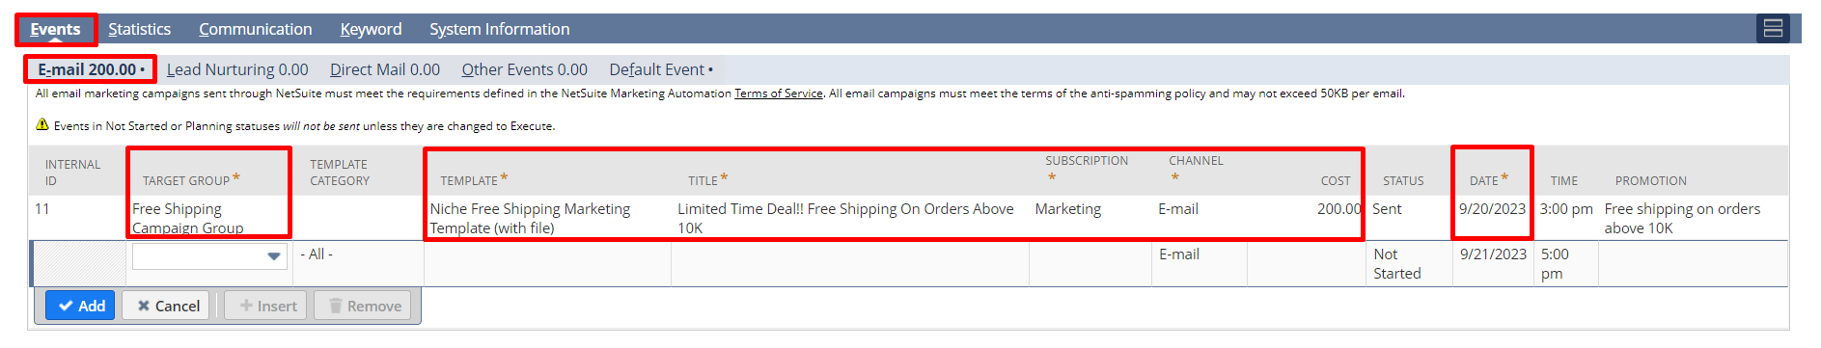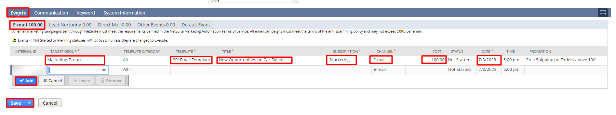

Login To Role: A/R Analyst
Return On Investment:
To review the Return on Investment, Create an Invoice, fill in the necessary details, and select the Lead Source as CAM2 Free Shipping Campaign.
Log in to NetSuite with the A/R Analyst Role and Navigate to Transaction Sales Create Invoice. 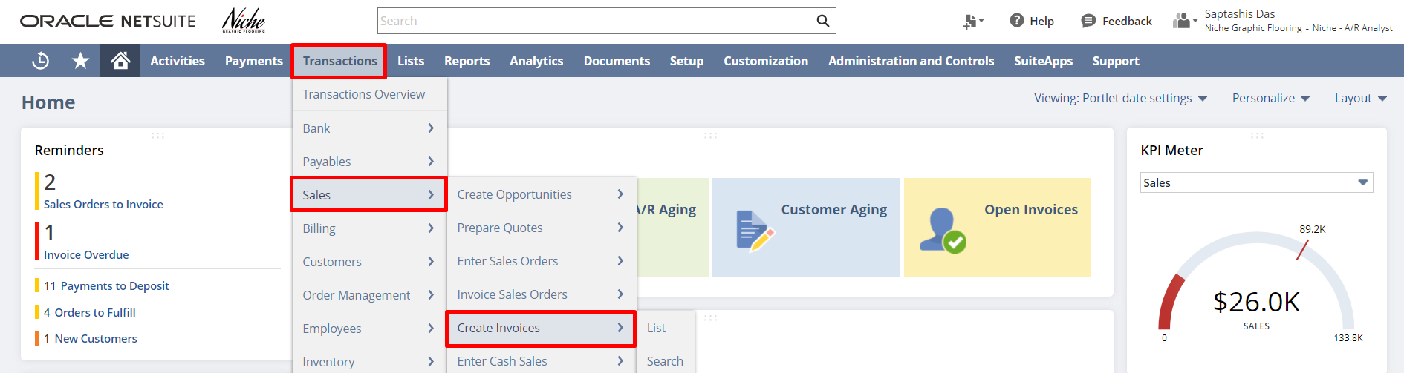

Select the Customer, Location, and fill in other necessary details. Select the Lead Source.
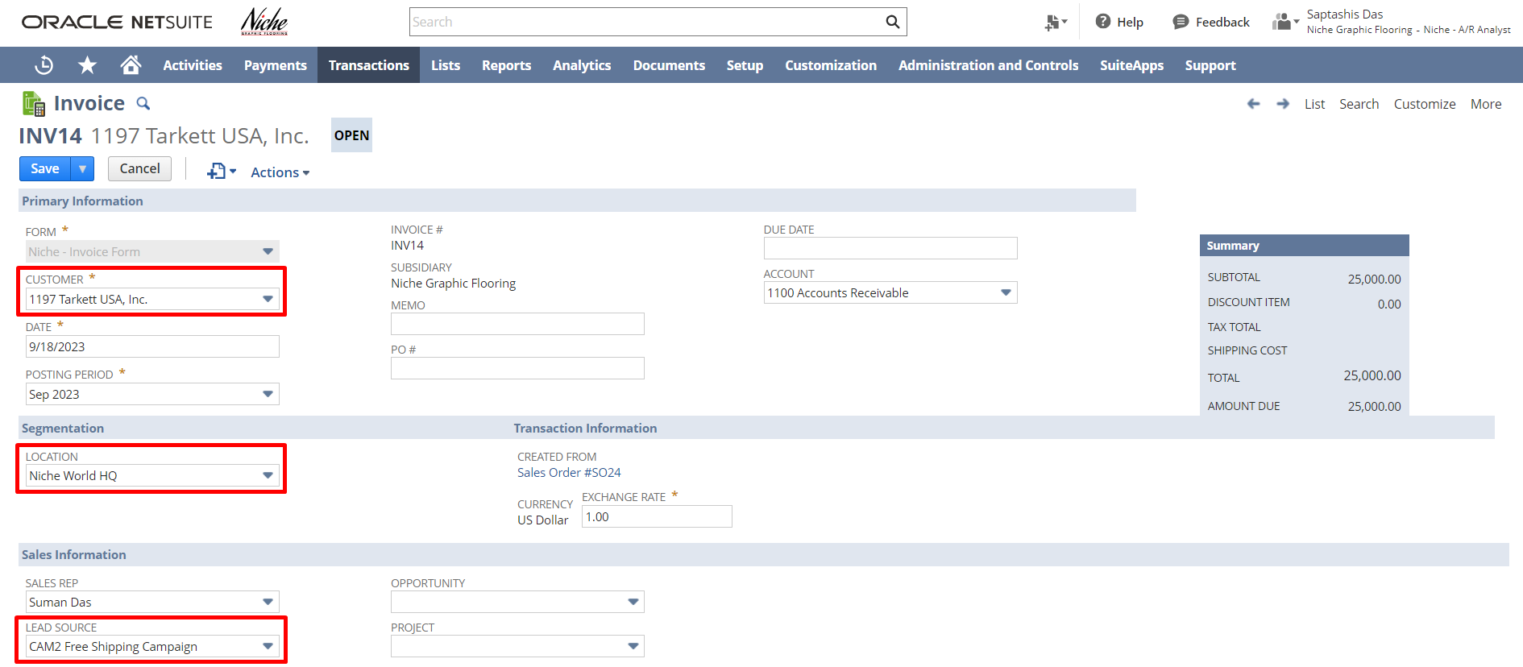

Under the Items Subtab, Select the Item, Rate, and Amount. Configure the Inventory Details. Click on Save.
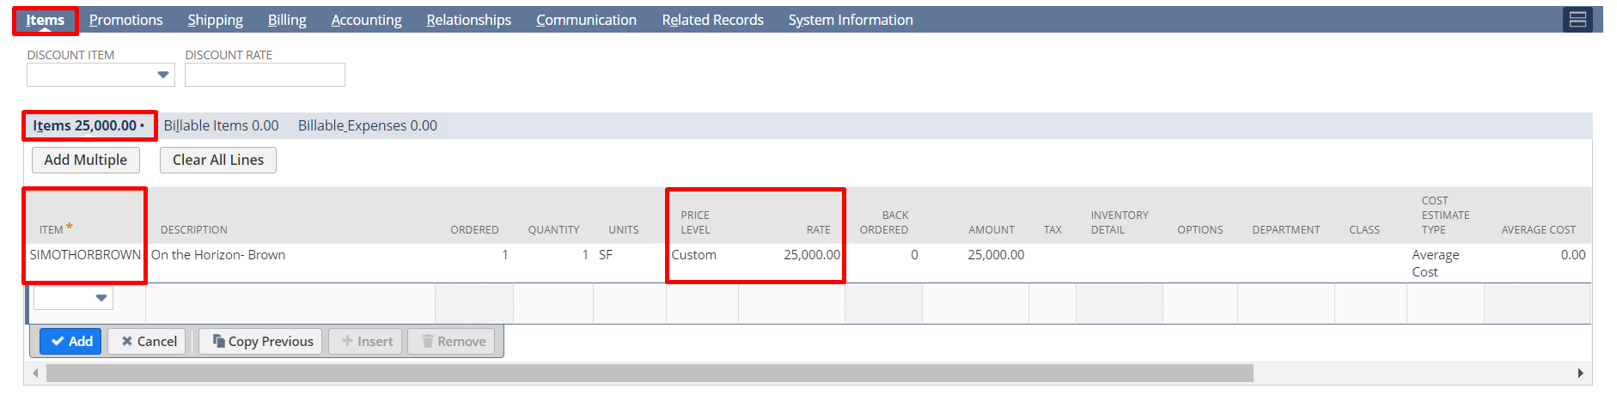
Under the Promotions subtab, you can select the promotion or check the Automatic Apply Promotions checkbox to apply for available promotions automatically.
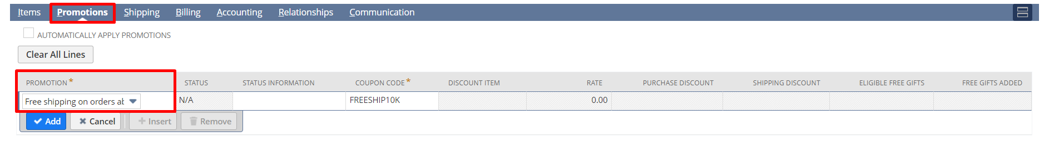
Under the Shipping subtab select the shipping carrier as “More” and the shipping method required. After that, click on “Save”.
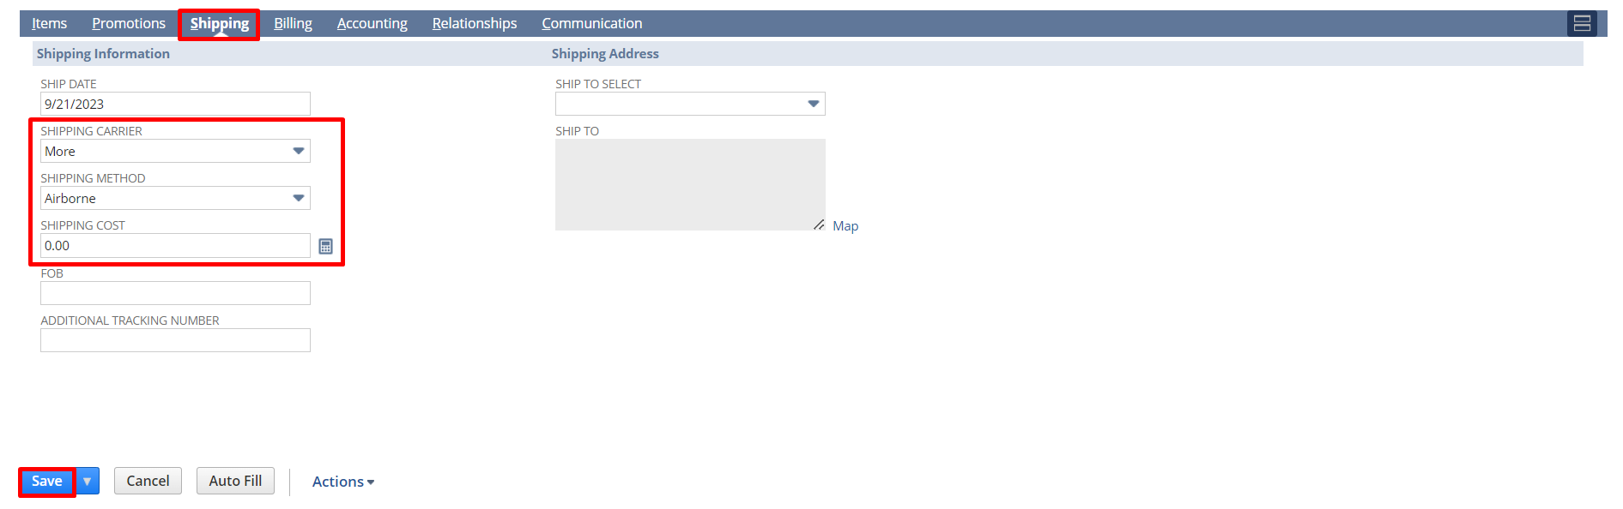

Login To Role: Marketing Manager
CAMPAIGN ROI ANALYSIS REPORT:
The Campaign ROI Analysis Summary report shows the profit and return on investment (ROI) for each marketing campaign. It also shows the number of leads, prospects, and customers generated. Campaigns are grouped by campaign category.
Profit is calculated by deducting the cost of the campaign from the amount generated by sales transactions with the campaign's lead source. ROI is calculated by dividing the profit by the cost of the campaign.
Viewing CAMPAIGN ROI ANALYSIS REPORT:
Navigate to Reports Marketing Campaign ROI Analysis.
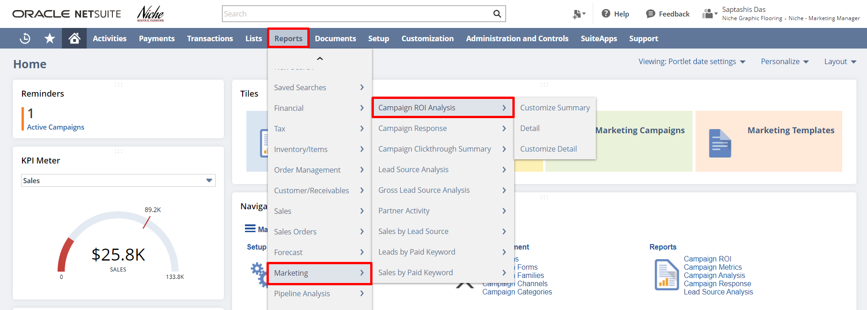

This will redirect you to the Campaign ROI Analysis Summary page where you can view the Cost, Revenue, Profit, etc., and click on View Detail to view The Campaign ROI Analysis Detail Report.
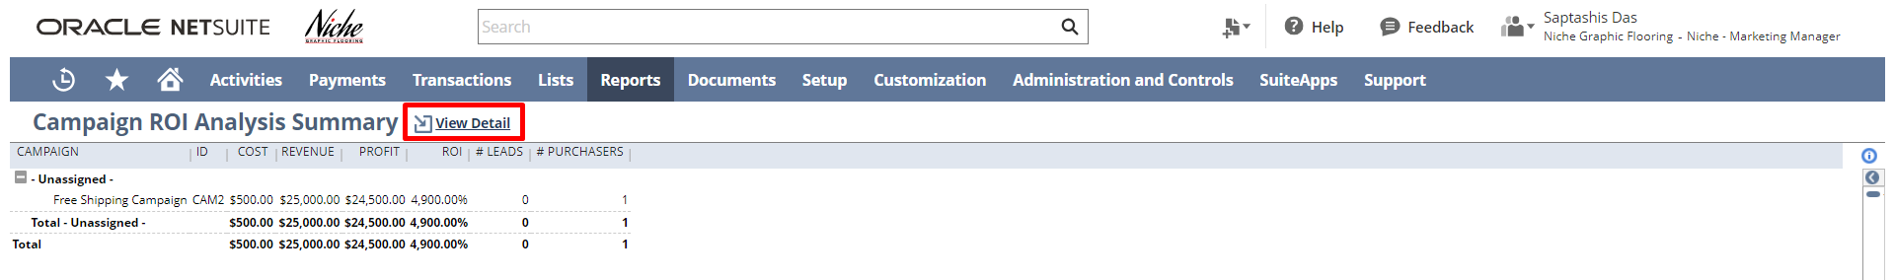

The Campaign ROI Analysis Detail report shows the profit for each scheduled event of your marketing campaigns. It also shows the number of leads and prospects generated. Campaign events are grouped by the campaign.
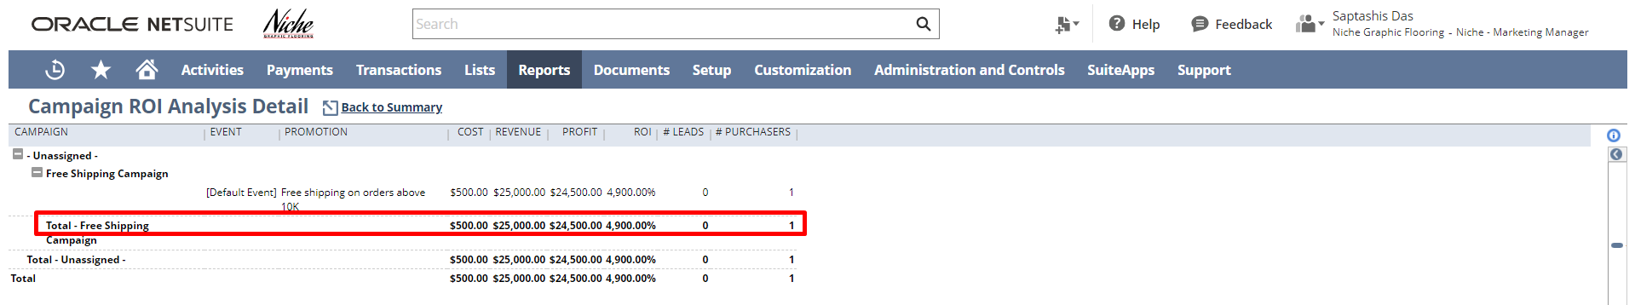

You can review other reports based on your requirements.

Please utilize the below feedback link for the Marketing to ROI module:
https://form.typeform.com/to/woCmtXub

Signature: ________________________________
Date: _____________________________________

Disclaimer:
Upon signing off on the process flow document, you are confirming that the process has been set up per the SOW within NetSuite per your business's needs. Any changes or modifications requested after sign-off will need to be a "change request" at an additional fee.

*** PLEASE ensure that you have logged into NetSuite and tested the process prior to signing off on the setup. Paapri requires sign-off on this document prior to moving forward with any additional design meetings.

